NETWORK FUNDAMENTALS AND BUILDING NETWORKS

NETWORK TOPOLOGIES

TASK1: Draw and label diagrams of star, bus, and mesh network topologies on paper or using any drawing tool. For each, write one real-world app or service (like WhatsApp, Flipkart, or IPL streaming) that could use that topology and explain why in 1-2 lines.
- STAR TOPOLOGY
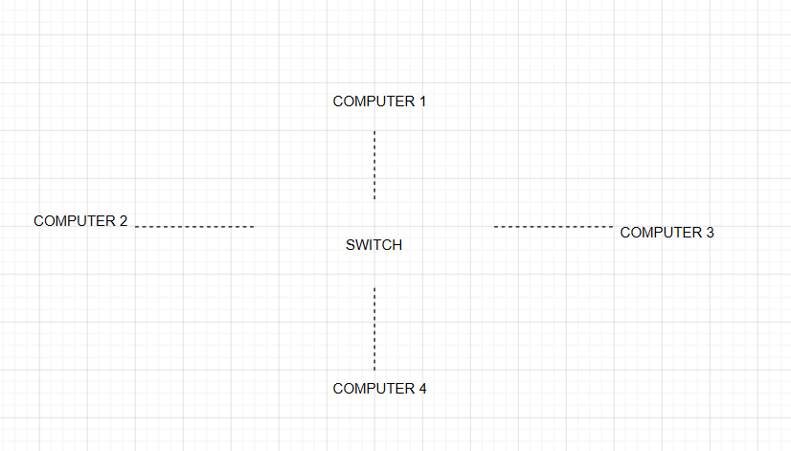

Instagram servers use a Star Topology because all users connect through a central server, making communication fast and easy to manage.
- BUS TOPOLOGY
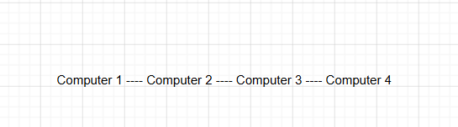

A Bus Topology is suitable for a small network because it is simple and low-cost.
- MESH TOPOLOGY

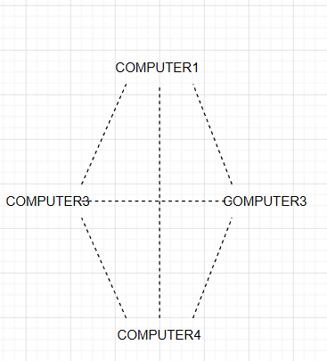

Mesh Topology provides multiple paths for data, ensuring reliable streaming even if one connection fails. ex: IPL live streaming

TASK2: Create a comparison table listing at least four pros and four cons for each of these topologies: star, bus, ring, mesh. Include a column for 'Best Use Case' and give an example from apps you use (e.g., Instagram, Zomato, Paytm).
Topology | Pros | Cons | Best Use Case
Star | Easy to manage, Easy to add devices, Fast performance, Easy troubleshooting | Needs more cables, Central device failure affects network, Higher cost, Depends on switch | Instagram, Paytm
Bus | Low cost, Simple setup, Less cable, Easy for small networks | Slow with many devices, Difficult troubleshooting, Single cable failure affects network, Limited expansion | Small office network
Ring | Equal data access, No data collision, Good performance, Organized communication | One failure can stop the network, Difficult to expand, Hard maintenance, Slower repair | Token Ring networks
Mesh | Very reliable, Multiple data paths, High speed, No single point of failure | Expensive, Complex setup, More cables, Difficult maintenance | Data centers, IPL Streaming

TASK3: Imagine you are designing a new multiplayer mobile game like PUBG or Free Fire. Choose a suitable network topology for the game servers and justify your choice in 3-4 lines, mentioning how it would impact speed, reliability, and cost
I would choose a Star Topology for a multiplayer game like PUBG or Free Fire. All players connect to a central game server, which manages the game data. This provides fast communication, easy management, and reliable gameplay. Although the server increases the cost, it offers better performance and supports many players at the same time.

TASK4: Given this scenario: A small Flipkart-style warehouse wants to connect 8 computers for order processing and inventory updates. Recommend a network topology, sketch a quick diagram, and explain your reasoning in 2-3 lines.<br><br><em><strong>Hint:</strong> Consider factors like cost, ease of troubleshooting, and future expansion.</em>
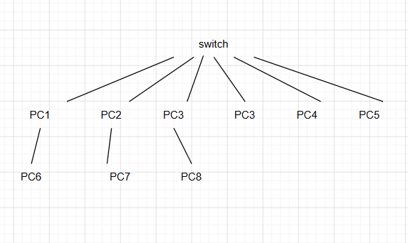

I would recommend a Star Topology. All eight computers would connect to a central switch. This setup is easy to install, simple to troubleshoot, and allows new computers to be added in the future without affecting the existing network.

